DESIGN BRIEF – UPCYCLING AN OUTFIT

BACKGROUND
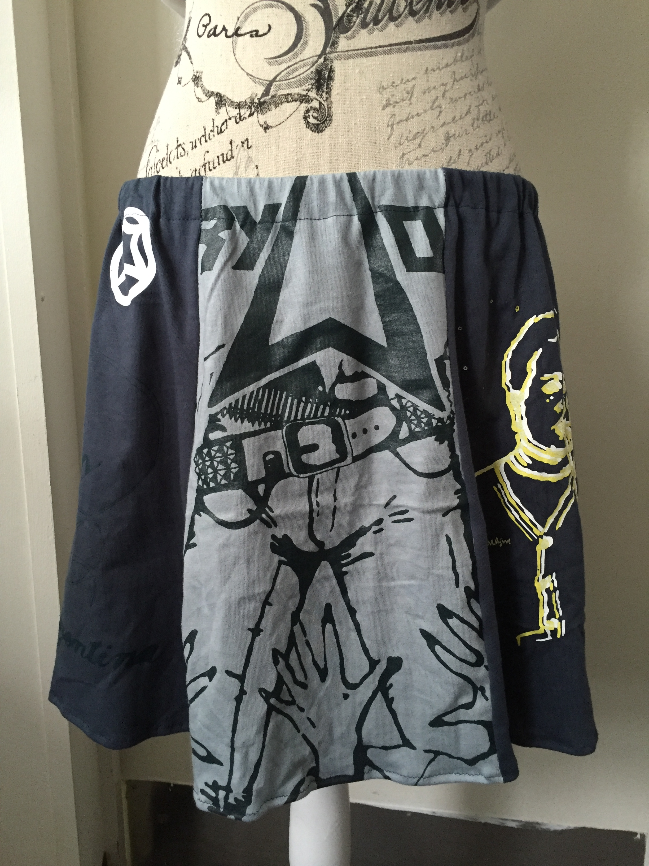
Sustainability in the textiles industry has become a hot topic due to the carbon footprint it leaves behind, especially with the increase in the amount of textiles waste in recent years. This is a result of several issues in the textiles industry. A major contributing factor is fast fashion: where there are constant changes in fashion trends, with new fashion lines being released every 6 weeks by some companies. Fast fashion results in an enormous amount of barely used clothes being dumped in landfill.

Recycling is one way of reducing the amount of clothes dumped in landfill, but this in itself increases the pollution due to the recycling processes. Upcycling, where unwanted textiles products are repurposed into new creations, is a different and very creative method of reducing waste.

You will find more information on sustainability in the textiles industry and upcycling at www.alamadatextiles.weebly.com/year-9

STATEMENT OF INQUIRY
Students will understand that combining different ideas in creative ways can lead to innovative new products through an inquiry into the potential impact of repurposing discarded resources.

INQUIRY QUESTIONS:
Factual— How is upcycling different to recycling? What impact does the textiles industry have on the environment?
Conceptual— What steps can we take to improve sustainability in the textiles industry?

Debatable— How can we use discarded textiles products to create products of higher value?

YOUR DESIGN BRIEF
To do your part to reduce textiles waste at your school, you will design and produce an entire outfit out of used and/or discarded textiles products. As a designer, your project needs to:
- comprise of a complete outfit (eg top and shorts, dress, top and skirt etc);
- have 90% of the materials originating from repurposed materials (you can choose to use 50% repurposed materials if 90% is too challenging);
- be designed appropriately for display in the school; and
- appeal to your own unique style.

Upcycling an Outfit

PRODUCTION JOURNAL
Throughout your project, you should keep record of the following in your production journal:
- make research notes;
- formulate ideas for this project;
- effective planning and management of your project;
- reflect on your process; and
- evaluate the finished design.

What to do for your presentation/report:

For this project, you will produce a presentation style report (using software such as PowerPoint, Keynote or Prezi). You will need to include photos of your progress throughout the semester.

Use the following headings/sections to structure your presentation:

Ideation

Investigation

Design

Planning and Management

Production Journal

Evaluation

IDEATION
For your presentation:
- Explain your design brief (see first page).
- Describe the product that you will be making. What is the need for this product?
- Explain the reasons why you chose to produce this item.

INVESTIGATION
The investigation for this project is a major part of your assessment. You will need to carry out separate investigations on upcycling and sustainability.

Upcycling textile products
  - What is upcycling?
  - How is upcycling different to recycling? Create an annotated Venn Diagram to display these differences.
  - Investigate other designers’ upcycled products. What sorts of products have been upcycled? Create a Pinterest board with your findings (follow Alamanda Textiles on Pinterest). Include at least five examples of upcycled products in your presentation.
  - Choose one upcycled product to investigate in more detail. What were the original items? How were they upcycled into the new item? What do you like/dislike about this product?
  - How do you think you can incorporate discarded textiles products in your own upcycled outfit design?

Sustainability in the textiles/fashion industry
  - Describe what some of the global concerns to sustainability in the textiles industry are. For example, the amount of textiles waste sent to landfill, how this waste is transported to landfill, the greenhouse gases released by this waste when in landfill. Why is this a problem for the environment?
  - Choose a fibre to investigate in detail – either natural, synthetic or regenerated.
    - How is this fibre produced? What are the environmental impacts with the production of this fibre?
    - What are the properties of this fibre?
    - What sort of textile products is this fibre used to make?
    - What are the costs of the production of this fibre? How does it compare to a different type of fibre (for example, if investigating synthetic polyester, compare it to a natural fibre, such as cotton. You may want to pair up with another student who is investigating a different fibre).
    - Can this fibre be recycled? If so, how is it recycled? What are the environmental impacts with recycling this fibre?
    - When this fibre is dumped in landfill, how long does it take to decompose? Does it decompose? What are the environmental impacts of this fibre decomposing, or not decomposing?

DESIGN
- Look at the sewing patterns available to help you with your designing.
- Brainstorm your ideas – sketches, photos, clippings, notes etc.
- Sketch your ideas on paper, sketching different angles, making comments.
- Choose your final design within your known constraints and objectives (time, equipment, skill level, resources). Produce detailed, annotated drawings of your design on A3 paper. In this final design, you need to include the following information:
  - Draw your design from different views: front, side, back. Include notations on your designs, for example colour, fabric, zips, buttons, special features etc.
  - Your body measurements (or those of your model).
  - The discarded textiles products that you will be upcycling. You can choose these based on colours, fabrics, patterns, amount of fabric available, buttons, zippers etc. You can use the textiles products supplied in the classroom, or bring in your own discarded products to upcycle from home or an Op Shop, such as the Salvos.
- Discuss your design. What were your inspirations? Did you find inspiration from other upcycled work, other fashion, from the original textile product itself?
- Discuss the fabrics you used. What fibres are they made from? (You may need to look at the care label). Why did you choose this type of fabric to make your design?

PLANNING AND MANAGEMENT
- Write out your production steps in a table format. Make sure you include all the details so other students would be able to following your production if they were to make a copy of your designed product. You also need to include a timeline for each step and keep on track each week.
- If you modify your plan for any reason, such as for time management purposes, or you have changed your mind about your design, make sure you make a note of this in an updated version of your production plan.
- Establish materials and equipment needed to make your products.
- Keep your journal up to date during the production process and be prepared to show your teacher at each lesson. Write this up formally for assessment at completion of your project.

PRODUCTION JOURNAL
- Follow your production plan to create your product/s.
- Document each production step as you work (make notes and take photos) and include these in your journal. Write explanations of what you are doing and interpret your drawings with annotations.
- During production, you need to make appropriate selection and safe use of tools, equipment, fabrics, materials and components to carry out processes appropriate to the fabrics and materials to produce a quality product.
- Keep an up to date reflection on your progress and alter plans as appropriate. Progress and changes to plans should be reflected upon and altered to your project as appropriate.

EVALUATION
Create an evaluation criteria based on the following questions in order for you to self-assess your design and production:
- In what ways does your product fulfil the design brief? In what ways does it not meet the brief? Consider the following:
  - Have you made a complete outfit?
  - Does your product/s fit yourself or your model?
  - Have you used 90% (or 50%) repurposed materials?
  - Does your product appeal to your own unique style?
- What do you think of your overall design? What changes would you make?
- Are you happy with the textiles you chose? Would you make adjustments next time?
- Is the colour scheme exactly what you expected? How would you change the scheme if remaking your product?
- How were your time management skills during the investigation, design and creation of your product?
  - Did the project take too long to make? How could you reduce the production time?
  - Make recommendations for future productions — what might you do differently in your production plan?
- Would it be easy to set up a production line for the manufacture of your product?
- Are the techniques (eg. cutting, machine sewing, overlocking, hand sewing etc.) you used to make your solution adequate/suitable? How would you improve these techniques? Will the product be durable? Were the techniques well executed?
- Is the product the right size/shape?
- What are the views of other people regarding your design and final product?

REFLECTION

Identify and reflect upon your learning process and development in textiles and design.

Points to be covered in your reflection:

What has your progress been like throughout the term

Zippered case

Designing/producing your upcycled product

What are your strengths in textiles? Why? How can you extend your strengths?

What have been your biggest challenges and weaknesses? Why? What steps can you do to improve them?

How do you think your time management skills are going? What improvement could you make to this area?

What are you most proud of with your achievements in textiles? Why?
**Please include examples and photographic evidence or your work throughout your reflection.

